Activity- 6
Case Analysis – Avoiding Misleading Proportions
Question 1 – Truncated Y-Axis in Sales Growth
The retail company has monthly sales ranging from ₹95 lakhs in January to ₹105 lakhs in June. The bar chart starts the Y-axis at 90 instead of 0, which makes the sales growth appear much larger than it actually is.
Given Data
Month | Sales (₹ lakhs)
January | 95
February | 97
March | 99
April | 101
May | 103
June | 105

- Why is the chart misleading?
The chart is misleading because the Y-axis starts at 90 instead of 0.
Actual increase in sales:
105 - 95 = 10 lakhs
Percentage increase:
(10 / 95) × 100 = 10.53%
Therefore, the actual sales growth is only 10.53%.
However, because the Y-axis begins at 90:
January visual height = 95 - 90 = 5
June visual height = 105 - 90 = 15
Therefore:
15 / 5 = 3
So, June appears three times as high as January in the chart, even though the actual sales increased only from ₹95 lakhs to ₹105 lakhs.
2. Visualization principle violated
The visualization principle violated is accurate and proportional representation of data.
Bar charts use the length of bars to represent numerical values. Therefore, a truncated baseline can exaggerate differences between values.
The Y-axis should normally begin at zero when using bar lengths to represent magnitude.
3. Improved visualization method
The improved method is to use a bar chart with the Y-axis starting from 0.
The chart should have:
- Months on the X-axis.
- Sales in ₹ lakhs on the Y-axis.
- Y-axis beginning at 0.
- Equal-width bars.
- Equal intervals on the Y-axis.
- Clear data labels.
A line chart can also be used if the main purpose is to show the monthly sales trend.

R Code
# Monthly sales data
month <- c("January", "February", "March",
"April", "May", "June")

sales <- c(95, 97, 99, 101, 103, 105)

# Create data frame
sales_data <- data.frame(month, sales)

# Create bar chart with zero baseline
barplot(
sales_data$sales,
names.arg = sales_data$month,
main = "Monthly Sales Growth",
xlab = "Month",
ylab = "Sales (₹ lakhs)",
ylim = c(0, 110),
col = "skyblue"
)

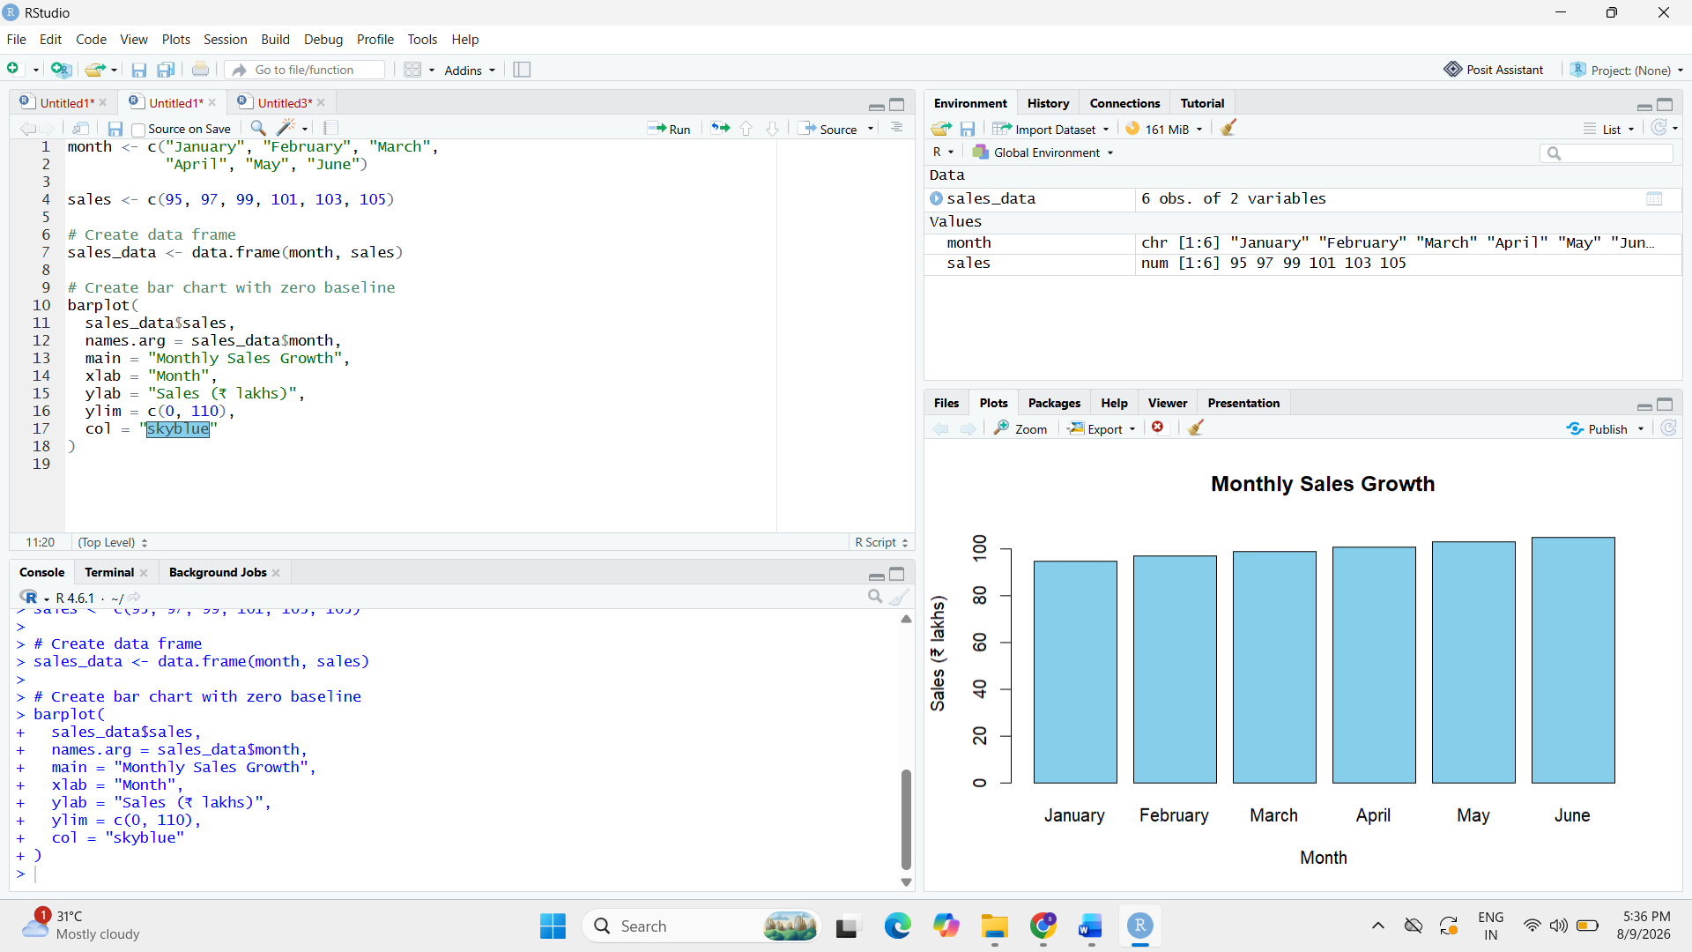
The R program creates the improved bar chart with the Y-axis beginning at 0, preventing the visual exaggeration caused by the truncated axis.
4. How could the misleading chart influence business decisions?
The misleading chart could make the marketing team and management believe that sales have increased dramatically.
This may lead to:
- Overestimating the success of marketing campaigns.
- Increasing the marketing budget unnecessarily.
- Setting unrealistic future sales targets.
- Making inaccurate sales forecasts.
- Allocating resources based on an exaggerated perception of growth.
Therefore, accurate visualization is important because business decisions should be based on the actual magnitude of change rather than an exaggerated visual representation.

Question 2 – Pie Chart with Incorrect Proportions
A university has four departments with the following student enrollment. The original pie chart incorrectly represents the proportions as approximately 50%, 30%, 15%, and 15%.
Given Data
Department | Students
Computer Science | 420
Electronics | 280
Mechanical | 200
Civil | 100
1. Calculate the correct percentage for each department
First, calculate the total number of students:
Total students = 420 + 280 + 200 + 100
Total students = 1000
Computer Science
Percentage = (420 / 1000) × 100
Percentage = 42%
Electronics
Percentage = (280 / 1000) × 100
Percentage = 28%
Mechanical
Percentage = (200 / 1000) × 100
Percentage = 20%
Civil
Percentage = (100 / 1000) × 100
Percentage = 10%
Therefore, the correct proportions are:
Department | Students | Correct Percentage
Computer Science | 420 | 42%
Electronics | 280 | 28%
Mechanical | 200 | 20%
Civil | 100 | 10%
Total | 1000 | 100%

2. Why is the displayed chart misleading?
The displayed pie chart is misleading because the slice sizes do not match the actual student enrollment.
The correct percentages are:
- Computer Science = 42%
- Electronics = 28%
- Mechanical = 20%
- Civil = 10%
But the incorrect chart shows approximately:
- Computer Science = 50%
- Electronics = 30%
- Mechanical = 15%
- Civil = 15%
For example, Civil actually represents only 10% of the total students, but the chart shows it as approximately 15%.
Similarly, Computer Science actually represents 42%, but the chart makes it appear to represent 50%.
Therefore, the visual proportions do not accurately represent the underlying data.
3. Alternative chart for better comparison
A bar chart would be a better alternative because it allows the viewer to compare the number of students in each department more accurately.
A bar chart can display:
- Department names on the X-axis.
- Number of students on the Y-axis.
- Equal-width bars.
- A zero baseline.
- Clear numerical labels.
R Code
# Student enrollment data
department <- c("Computer Science", "Electronics",
"Mechanical", "Civil")

students <- c(420, 280, 200, 100)

# Create data frame
enrollment_data <- data.frame(department, students)

# Create bar chart
barplot(
enrollment_data$students,
names.arg = enrollment_data$department,
main = "Student Enrollment by Department",
xlab = "Department",
ylab = "Number of Students",
ylim = c(0, 450),
col = "skyblue"
)
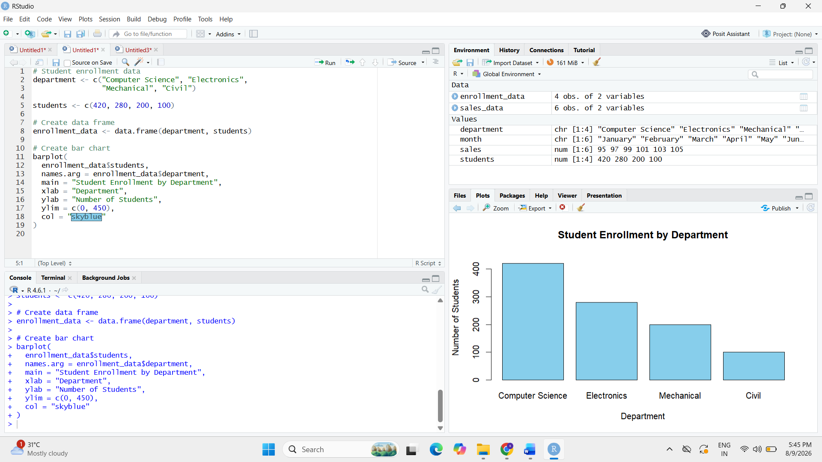
4. How could such errors affect institutional planning?
Incorrect proportions can lead to wrong conclusions about the size and requirements of different departments.
For example:
- The university may overestimate the number of Computer Science students.
- Resources may be allocated based on incorrect enrollment proportions.
- Faculty requirements may be estimated incorrectly.
- Classroom and laboratory capacity may be planned inaccurately.
- Department budgets may not reflect actual student strength.
- Future admission and infrastructure decisions may be affected.
Therefore, accurate proportions are important for effective institutional planning and resource allocation.

Question 3 – Unequal Bar Widths in Revenue Comparison
A software company compares the annual revenue of four products. The designer uses bars with increasing widths, causing Product D to appear nearly three times larger than Product A, even though the actual revenue difference is much smaller.
Given Data
Product | Revenue (₹ Crores)
A | 60
B | 75
C | 90
D | 105
1. Identify the graphical error
The graphical error is the use of unequal bar widths in the bar chart.
In a standard bar chart, all bars should have the same width. The value should be represented only by the height or length of the bar.
Here, the designer increases the width of the bars from Product A to Product D. This makes Product D appear much larger than its actual revenue value.
2. How do unequal bar widths distort perception?
Unequal bar widths distort perception because viewers may interpret the total visual area of a bar as representing the revenue.
For example:
Product A revenue = ₹60 crores
Product D revenue = ₹105 crores
Actual ratio:
105 / 60 = 1.75
Therefore, Product D's revenue is 1.75 times Product A's revenue, not three times.
When both the height and width of the bars increase, the visual area increases much faster than the actual values. This makes Product D appear disproportionately larger.
3. Redesign the visualization using correct design principles
The chart should be redesigned using the following principles:
- All bars should have equal widths.
- Bar height should represent revenue.
- The Y-axis should start from zero.
- Equal intervals should be used on the Y-axis.
- Products should be clearly labelled.
- The same scale should be maintained for all products.
- No unnecessary 3D effects or perspective should be used.
- Data labels can be added to show the exact revenue values.

R Code
# Annual revenue data
product <- c("A", "B", "C", "D")
revenue <- c(60, 75, 90, 105)

# Create data frame
revenue_data <- data.frame(product, revenue)

# Create bar chart with equal-width bars
barplot(
revenue_data$revenue,
names.arg = revenue_data$product,
main = "Annual Revenue by Product",
xlab = "Product",
ylab = "Revenue (₹ Crores)",
ylim = c(0, 120),
col = "skyblue"
)
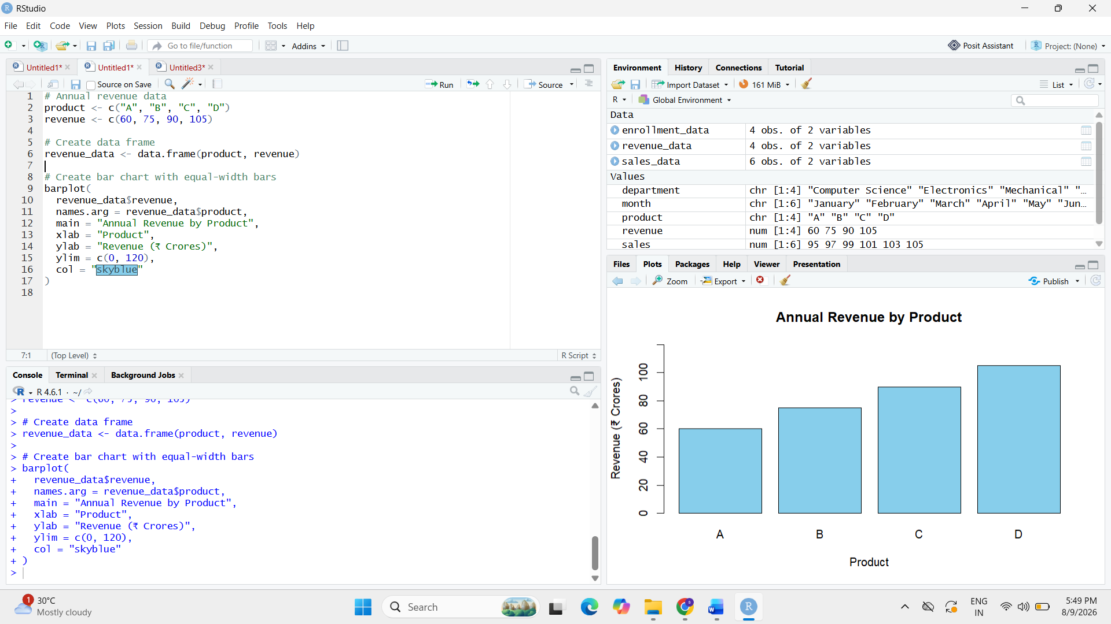
4. Possible consequences if investors rely on this chart
If investors rely on the misleading chart, they may believe that Product D is performing far better than the other products.
This could lead to:
- Investors overestimating the company's performance.
- Incorrect investment decisions.
- Excessive investment in Product D.
- Underestimation of Products A, B, and C.
- Incorrect assessment of product profitability.
- Poor financial planning and forecasting.
Therefore, equal-width bars and a consistent scale are necessary to ensure that investors receive an accurate representation of revenue.

Question 4 – 3D Column Chart Distortion
An energy company reports renewable energy generation from Solar, Wind, Hydro, and Biomass. A 3D column chart with perspective effects makes the Hydro bar appear almost 40% larger than Wind, even though the actual difference is only 10%.
Given Data
Source | Energy (GWh)
Solar | 450
Wind | 500
Hydro | 550
Biomass | 520
1. Why can 3D charts create misleading proportions?
3D charts can create misleading proportions because perspective, depth, viewing angle, and graphical effects change the apparent size of the columns.
A 3D column may look larger because part of its depth or surface is visually exposed. This can make the difference between two values appear greater than the actual numerical difference.
In this case, the Hydro column appears almost 40% larger than Wind because of the perspective effect, even though the actual values are much closer.
Therefore, 3D effects can make viewers interpret visual size incorrectly.
2. Compare the perceived difference with the actual difference
Wind energy = 500 GWh
Hydro energy = 550 GWh
Actual difference:
550 - 500 = 50 GWh
Percentage difference relative to Wind:
(50 / 500) × 100 = 10%
Therefore, the actual difference between Wind and Hydro is only 10%.
However, because of the 3D perspective, the chart makes Hydro appear almost 40% larger than Wind.
Thus:
Actual difference = 10%
Perceived difference = approximately 40%
The perceived difference is therefore much larger than the actual difference.
3. Recommend a better visualization
A simple 2D bar chart or column chart should be used instead of a 3D chart.
The improved visualization should:
- Use a 2D chart.
- Use equal-width bars.
- Start the Y-axis at zero.
- Use a consistent scale.
- Avoid perspective and depth effects.
- Display clear data labels.
- Use the same visual dimensions for all categories.

R Code
# Renewable energy data
source <- c("Solar", "Wind", "Hydro", "Biomass")
energy <- c(450, 500, 550, 520)

# Create data frame
energy_data <- data.frame(source, energy)

# Create 2D bar chart
barplot(
energy_data$energy,
names.arg = energy_data$source,
main = "Renewable Energy Generation",
xlab = "Energy Source",
ylab = "Energy (GWh)",
ylim = c(0, 600),
col = "skyblue"
)
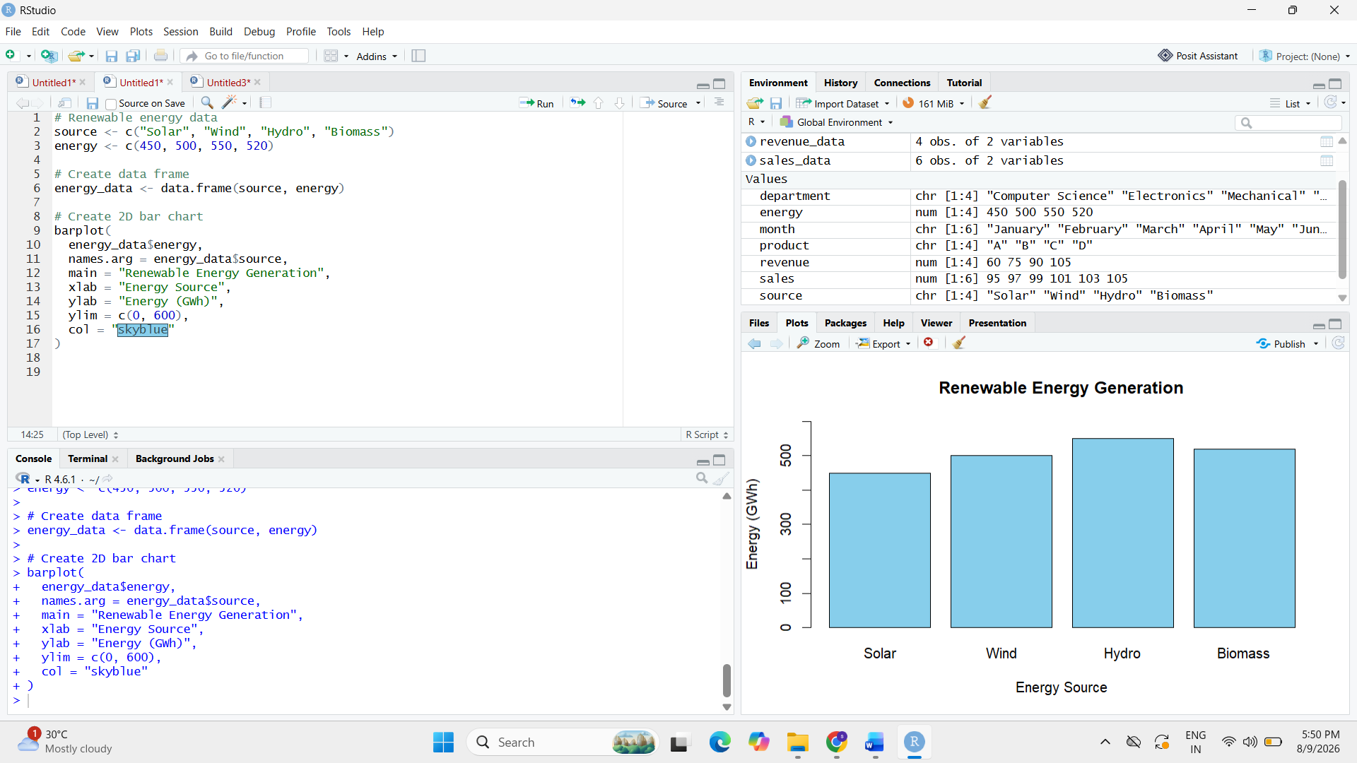

4. Importance of avoiding visual distortion in sustainability reporting
Accurate visualization is important in sustainability reporting because energy generation data may be used by management, investors, regulators, and the public to evaluate environmental performance.
Misleading visualizations can:
- Exaggerate renewable energy performance.
- Create incorrect perceptions about energy sources.
- Mislead investors and stakeholders.
- Affect sustainability-related decisions.
- Lead to incorrect comparisons between renewable sources.
- Reduce the credibility of the organization's reports.
Therefore, sustainability reports should use simple and accurate visualizations that represent the actual data without unnecessary visual distortion.

Question 5 – Bubble Chart with Incorrect Scaling
A healthcare organization compares disease cases across five districts. The analyst scales the bubble radius directly to the number of cases instead of scaling the bubble area, causing District E to appear much larger than District A.
Given Data
District | Cases
A | 150
B | 250
C | 350
D | 450
E | 550

1. Why is scaling the radius instead of the area misleading?
In a bubble chart, the visual quantity that viewers perceive is the area of the bubble.
The area of a circle is:
Area = πr²
If the radius is directly proportional to the number of cases, the area increases with the square of the number of cases.
For District A:
Cases = 150
For District E:
Cases = 550
Radius ratio:
550 / 150 = 3.67
Therefore, the radius of E is 3.67 times that of A.
But the area ratio becomes:
3.67² = 13.44
Thus, District E can appear more than 13 times larger in visual area than District A, even though the number of cases is only:
550 / 150 = 3.67 times
This exaggerates the difference between the districts.
2. Correct method for proportional bubble sizing
The bubble area should be directly proportional to the number of cases.
The required relationship is:
Bubble area ∝ Number of cases
Since:
Area = πr²
the radius should be calculated as:
r ∝ √(Number of cases)
Therefore, the radius should be proportional to the square root of the number of cases, rather than directly proportional to the number of cases.
This ensures that the visual area of each bubble correctly represents the number of disease cases.
3. Alternative visualization suitable for this dataset
A bar chart would be a better alternative because the dataset contains five districts and exact comparison of disease cases is important.
A bar chart can clearly show:
- Districts on the X-axis.
- Number of cases on the Y-axis.
- Equal-width bars.
- A zero baseline.
- Clear numerical values.
R Code
# Disease cases data
district <- c("A", "B", "C", "D", "E")
cases <- c(150, 250, 350, 450, 550)

# Create data frame
health_data <- data.frame(district, cases)

# Create bar chart
barplot(
health_data$cases,
names.arg = health_data$district,
main = "Disease Cases by District",
xlab = "District",
ylab = "Number of Cases",
ylim = c(0, 600),
col = "skyblue"
)
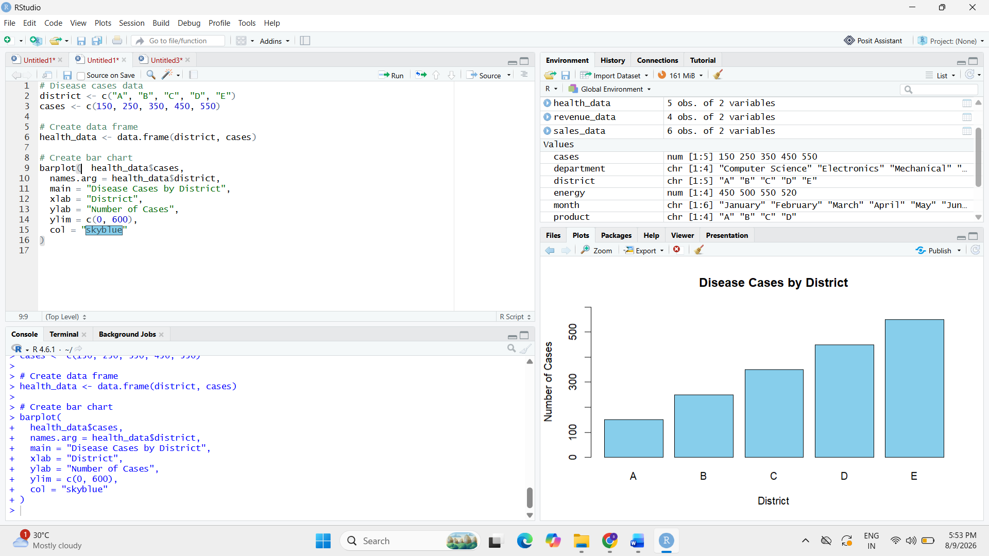
4. Potential impact on public health resource allocation
A misleading bubble chart can cause decision-makers to overestimate disease cases in certain districts.
This may result in:
- Excessive allocation of medicines to some districts.
- Incorrect deployment of healthcare workers.
- Misallocation of medical equipment.
- Incorrect prioritization of affected areas.
- Reduced resources for districts that actually need them.
- Inaccurate public health planning.
Therefore, disease data should be represented using accurate proportional scaling so that healthcare resources can be allocated according to the actual number of cases.

S. LAKSHITA
192524108

